|  |  |
| --- | --- |
| Group Number:- 5 |  |
| Team Members:-1) shreyas gore  2)Prajwal pawar  3)Madhura lakade |  |
| Submission Date:- 24th October 2025 |  |
| Submitted To:- shreyash atre |  |
| Project Type:- no code |  |

1. Introduction

This document outlines the system design and logical flow for a conceptual Over-The-Top (OTT) streaming platform, designed as a clone of popular services like Netflix. The primary goal of this project is to model the core functionalities of a modern streaming service, including user authentication, content browsing, subscription management, and various viewing modes, such as single-user and group-watch sessions. The design is presented through detailed pseudocode and a corresponding flowchart, which serve as the blueprint for the website. The project focuses on demonstrating a robust, user-centric flow that manages both free and premium content access.

2. Objectives

The core objectives of this project are to:

1. Model a Comprehensive User Authentication Flow: Design a secure process for user sign-in and new account registration.
2. Define Content Access Logic: Clearly delineate the conditions under which a user can access standard versus premium content, incorporating a subscription and payment gateway.
3. Establish a Multi-faceted Viewing Experience: Develop a logic that supports both solo viewing and an innovative "Watch With Friend" group session, including features like real-time communication enablement.
4. Outline the Content Discovery Process: Create a structured flow for browsing content by category (e.g., Trending, Comedy, Horror) and searching for specific titles.
5. Integrate Feedback Mechanism: Ensure the system includes a final step for collecting user feedback to facilitate continuous improvement.

3. Tools and Technologies Used

For the design and documentation phase of this project, the following tools were utilized:

| Tool/Technology | Purpose in Project |
| --- | --- |
| Pseudocode | To provide a high-level description of the system's operational logic and functions. |
| Flowchart | To visually represent the sequential steps and decision points within the system's core processes. |
| Markdown | Used for structuring and formatting the final project documentation for easy conversion to an editable Word file. |
| Draw.io | Used for drawing flowchart with high detailing and is easy to edit |

4. Project Overview

The project models a feature-rich OTT platform with a strong emphasis on user journey and content monetization. The system is divided into several interconnected functions that manage the user's lifecycle from initial login to content consumption and feedback.

Key System Functions:

| Function Name | Description |
| --- | --- |
| main_login_flow() | Handles user authentication. Redirects to account creation if login fails. |
| main_ott_flow() | The central hub, displaying the Home Page after successful login. |
| select_package() | Manages the subscription process, offering Silver, Gold, and Platinum tiers, and processing various payment methods (UPI, Card, PIN). |
| browse_section() | Enables content discovery through search and category filtering (All, Trending, Top, Comedy, Horror). |
| check_available() | Verifies content availability and initiates the watch() function if the movie is found. |
| watch() | Determines the viewing mode (Alone or With Friend) and checks for premium access requirements. It also includes a unique logic check: if release year < 2010, the user can watch immediately; otherwise, they are prompted to select_package(). |
| invite_friend_flow() | Manages the group-watch invitation process and checks the friend's premium status. |
| start_group_session() | Initiates the shared viewing experience, enabling mic and video conversation. |
| watch_movie() | The core playback function, which concludes with a call to take_feedback(). |
| take_feedback() | Collects user satisfaction data after viewing. |

System Pseudocode

The following pseudocode details the operational logic of the platform:

START

Display "Sign In" page

function main_login_flow():

Accept gmail_id, password

if credentials are valid:

Display "Login Successful"

Go to Home Page

main_ott_flow()

else:

Display "Create New Account" page

Accept gmail_id, password

Register new account

Go back to main_login_flow()

function main_ott_flow():

Display "Home Page"

function select_package():

Display packages (Silver, Gold, Platinum)

user_selects_package()

Accept payment details (UPI, Card, PIN, etc.)

Process payment

if payment successful:

Display "Payment Successful"

else:

Display "Payment Failed"

Retry or Exit

function browse_section():

Display Browse options (All, Trending, Top, Comedy, Horror)

Accept search input or category selection

check_available(search_input_or_category)

if release year < 2010 then function watch()

else select package()

function check_available(movie_name):

if movie is available:

watch(movie_name)

else:

Display "Not available. Search another movie."

browse_section()

function watch(movie_name):

choice = Get user selection (Watch Alone, Watch With Friend)

if choice == "Alone":

if movie is premium:

if user has premium:

watch_movie(movie_name)

else:

Display "This is premium. Buy premium."

select_package()

watch_movie(movie_name)

else:

watch_movie(movie_name)

if choice == "With Friend":

invite_friend_flow(movie_name)

function invite_friend_flow(movie_name):

Send link/invite to friend's email

if friend has premium:

start_group_session(movie_name)

else:

Display "Friend needs premium"

select_package()

start_group_session(movie_name)

function start_group_session(movie_name):

Enable mic and video conversation

watch_movie(movie_name)

function watch_movie(movie_name):

Play movie

take_feedback()

function take_feedback():

Accept user feedback

Display "Thank you"

END

5. Daily Progress Summary

This section is reserved for tracking the day-to-day activities and milestones achieved during the project's execution. Please fill in the details below based on your actual work log.

| Date | Activity/Task Completed | Status/Notes |
| --- | --- | --- |
| Day 1 | On this day we discussed our strategy to approach the problem  And to assess all problems we faced and then gave each member fixed work to do. | Strategy day |
| Day2 | Our goal was to do flowchart and pseudocode for an OTT platform clone and so we discussed and then finalized our flowchart we also added an extra feature which was “WATCH TOGEATHER”on day 2. | Flowchart done |
| Day3 | On this day we discussed and then finalized our pseudocode and then started working on our website. | Pseudocode done |
| Day 4 | On this day we discussed and corrected both flowchart and pseudocode logic. | Correction day |
| Day 5 | Started our documentation and got halfway | Documentation day |
| Day 6 | Completed our documentation and then corrected it | Documentation correction |

6. Screenshots

This section is dedicated to visual evidence of the project's design.the link of flowchart is provided below 

Placeholder for Flowchart Image

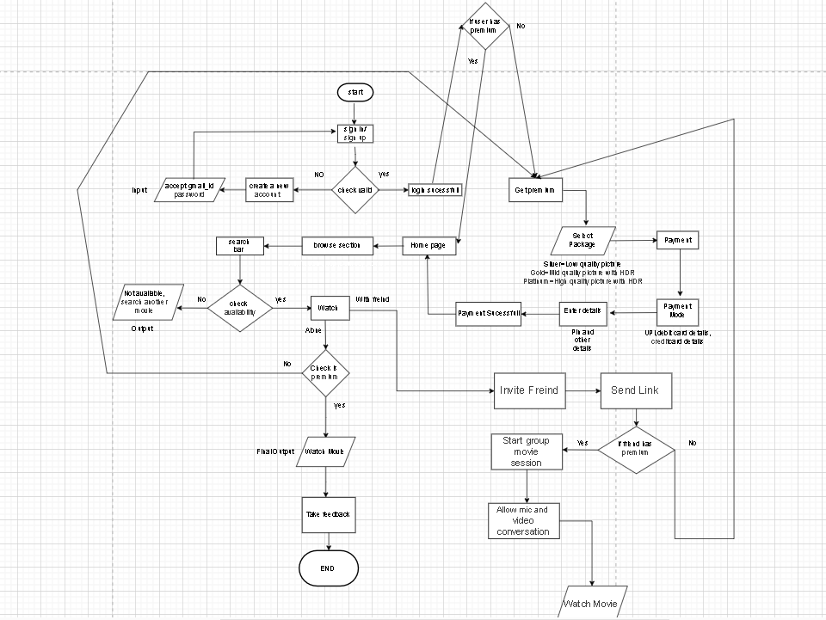

7. Learnings and Challenges

Learnings

The following key insights and skills were gained during the conceptual design phase:

* Modular System Design: Understanding the importance of breaking down a complex system (like an OTT platform) into discrete, manageable functions (main_login_flow, select_package, watch, etc.) to improve clarity and maintainability.
* Decision-Point Logic: Mastering the use of conditional logic (if/else statements) to handle diverse user scenarios, such as valid/invalid login, premium/non-premium content access, and different viewing choices.
* Flowcharting Best Practices: Gaining proficiency in translating abstract pseudocode into a standardized visual flowchart, which is crucial for communicating system logic to both technical and non-technical stakeholders.
* Complex User Journey Mapping: Successfully integrating multiple, inter-dependent processes, such as payment processing, friend invitation, and group session initiation, into a single cohesive user experience.

Challenges

The following challenges were encountered and successfully addressed:

* Integrating Subscription Logic: The main challenge was ensuring that the premium check was correctly implemented at multiple points: for watching a premium movie alone, and for initiating a "Watch With Friend" session, where both users must have premium access. The solution involved recursive calls to select_package() to ensure compliance.

8. Conclusion

This project successfully delivered a comprehensive conceptual design for an OTT streaming platform, complete with detailed pseudocode and a visual flowchart. The design effectively models the complexities of user authentication, tiered subscription management, and a modern, social viewing experience. The logical structure is sound and provides a clear, actionable blueprint for developers to begin the implementation phase. The system's modular nature ensures scalability and ease of future feature integration.

9. References

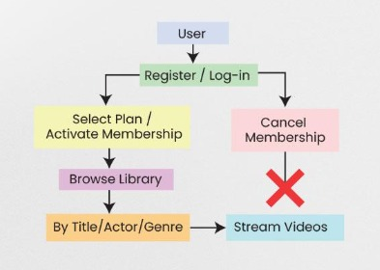

Used by shreyas gore for making of flowchart

✅ Final Note

We learned so much while making this project like how to make flowchart how to make pseudocode and most importantly how to use ai efficiently overall it is a great experience